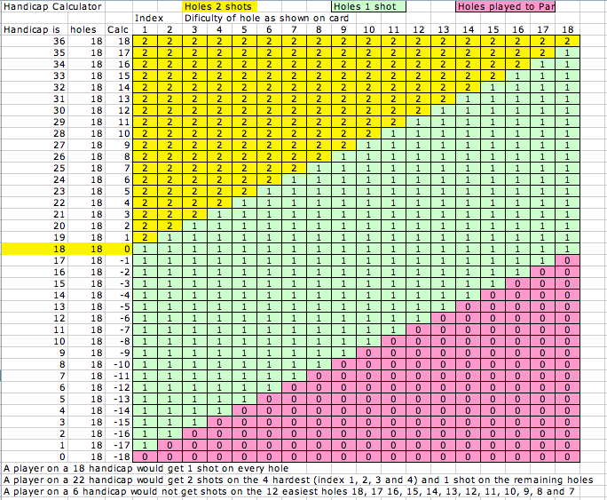
Handicaps
The course rates holes, giving each hole an index, index 1 is the hardest, index 18 the easiest, based on the difficulty of each of the 18 holes. Handicaps can range from -0 to 36, a player on 18 would get 1 shot on each hole. The better the player the lower the handicap.
A player’s handicap is calculated by deducting 18 from their handicap, a player on 22 would have plus 4 which means he gets 1 shot on each hole and 2 shots on the four hardest holes. This means that the player would get 2 shots for the 1st , 2^{nd,} , 3rd and 4th hardest holes (Index 1, 2, 3 and 4).
A player on less than 18 say on a 13 handicap would have a -5 this means that the player would not get shots on the 5 easiest holes on the golf course, 18, 17, 16, 15, and 14.
Handicap Calculator
A Player on 18 would get 1 shot on every hole shown in (Green)
A Player on a 24 handicap would get 2 shots on the 6 hardest holes (Yellow) (1, 2, 3, 4, 5 and 6) and one shot (Green) on the remaining holes. Look at the Calc to see your calculation.
A Player on a 6 handicap would only get shots on the hardest 6 holes (Green) and would not get shots on the 12 easiest holes (Red). Look at the chart to see your handicap shots.

Games
Stableford
Involves scoring points based on results at each hole. Using the index for each hole, players are able to make a mental allocation of their full handicap for each of the 18 holes.
For example, a player on a handicap of 18 will add one shot to the par value of each hole to determine their own par for the hole. Thus a hole rated as a par 4 becomes a par 5 for the player.

The points scoring method is then calculated by allocating two points for a par, one point for one over, three points for one under, four points for two under, and so on

1 over handicap Par = 1 pt
Par = 2 pts
1 under = 3 pts
2 under = 4 pts
3 under = 5 pts etc.

Players who exceed their own par by two strokes score no points for the hole and, since they cannot improve on that result, they should pick up their ball. (Unless a novelty prize is available).

When marking the scorecard, the number of strokes taken must always be shown for holes where points are scored. Thus, the card records both strokes and points. At the end of the round all points scored are added up and the player having the highest number of points is the winner.

Aggregate Stableford (2 Player – 4 player)
The net scores is determined by adding together the individual scores of the Team members. (Points scored 1, 3 , 3 & 0 for 4 players = 7 points agregate)

Stableford Pairs (2 Player) Best Score
Both players play their own ball throughout; For example, Players A and B form one team, at the end of each hole, the high score from either of the two partners on each team is that team's score.
The net score is determined by selecting the best individual score of either of the Team members. i.e. on one hole, player A scores 1 point, Player B scores 3 points = result is 3 points (best score) continue adding the best score by either player for each hole, highest Stableford score is the winner.

Russian Stableford
This is a pairs event. The two stableford scores are multiplied together to create a team score on a hole by hole basis. For example, if one of the partners scores 3 points and the other scores 2 the result is 6, but if one player scores 2 and the other wipes the hole the result is 0 or a wipe for the pairing. In effect both players must score on each hole, even 3 x 1 is 3 points scored.

Stroke
Players record the number of strokes taken at each hole and total them up at the end of a given round, or rounds. The player with the lowest total is the winner. In handicap competitions, the player would subtract their handicap from the total (gross) score to generate their net score, and the player with the lowest net score is the winner. Additional winners can also be for best Gross score.

Par (Bogey) competition challenges players to beat their own handicap par. If players better their par, they score a ‘+’ (plus) for the hole. If players equal their own par, they are said to have halved or squared the hole which is scored with an ‘O’. If par is not achieved, a ‘-‘ (minus) sign is recorded. At the end of the round the plus and minus signs are added and the net result written in as so many ‘up’, ‘down’ or ‘all square’. Player with the highest plus score is the winner.

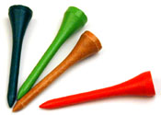


If your handicap is
22-
18
4
Deduct 18 holes then the number left (4) is the hardest holes index
1, 2, 3 and 4 to get an extra stroke.

If your handicap is
13-
18
5-
Deduct 18 holes then the number left is negative (-5) is the 5 easiest holes index 18, 17, 16, 15 and 14 get no stroke.


The Pro Shop is fully stocked with top brand golf equipment, Henry Griffitts, Wilson, Ping, Bridgestone, Titleist, Cobra and many more. Full sets of clubs from as little as $299.00 or package deal with bag, buggy and putter from $399.00. There is a full range of accessories, shoes, bags and buggies.
Or if you can’t find the gift for the golfer that seems to have everything, how about a gift voucher?
Phone 08 9457 8999
The SCUDS Social Golf Club play 11 Par rounds, 15 Stroke rounds, 12 Stableford rounds and 14 Novelty rounds plus
A Club Championship, Monthly Medal and various Inter Club Trophies and 10 Away games at Araluen, Meadow Springs, Marangaroo, Secret Harbour, Pinjarra, Marri Park, Margaret River, Dunsborough Lakes, Bunbury, and more. We even have an annual South West Tour and an International Tour.
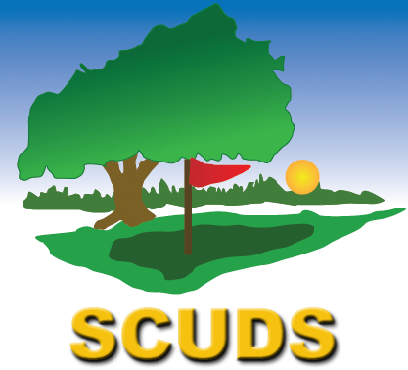

Ph: 9490 1465
General
(To be read in conjunction with local course rules)

1 Preferred Lie, shall be taken in accordance with the course rules, at Whaleback on the fairway, this is one club length, no nearer the hole.

2 Bunkers Shall be played as the ball lies, unless the bunker is damaged, or the ball is in a shoe imprint, animal scratching or water, after agreement with your marker, it may be smoothed and placed.

3 Slow Play The lowest handicapper in each group shall ensure that the group maintains its place in the field behind the group in front. Slow groups or groups searching for lost ball should immediately call the other group through.

4 Honour Players should play when ready at the next tee off, the group should maintain its place in the field irrespective of whose honour to play.

5 Combined games Players paired in combined games, where a player does not have a partner (i.e. pairs, playing in a group of 3), The lowest handicap player will combine with each player to form two groups of pairs.

6 Dress Code Players should comply to the dress code standard at Whaleback Golf Course.

Par Bisque
As in "par" but handicap strokes may be taken as a player decides, up to the maximum of his handicap. The decision about the number of handicap strokes to take at each hole and the resultant score is made at the end of each hole and before play on the next hole is commenced.
i.e. A player on an 18 handicap scores a 5 on a par 4 hole resulting in a square (halved) but he may elect to use two handicap strokes to score a ‘+’ (plus) for the hole, 5 less 2 shots = a 3 as a ‘+’ (plus) for the hole. The trick is not to use up too many handicap shots before completing the round.

Ambrose Competition
This event can be played as a two, three or four-person event, although the four-person event is the most popular. Each player plays a tee shot at each hole. The Captain then selects the best drive, which is then marked by its owner. The other members retrieve their balls and in turn place their ball on the fairway (one club length no nearer the hole, or if in the rough, drop in the rough within one club-length of the selected position (no nearer the hole) and play their second shots). If in a bunker smooth and place. This procedure of selecting the best position continues until a ball is holed. When on the green, balls are placed on the selected marked spot until holed.

This event can be played as a gross event, the Club Captain will detemine the number of drives per team, with each group having a spread of handicaps, or as a handicap event where a fraction of the aggregate handicaps is used. The most common method of determining handicap is:
Two-person event – ¼ of aggregate stroke handicap;
Three-person event – ¹/₆ of aggregate handicap;
Four-person event – ⅛ of stroke handicap.

4 Ball Stroke (2 Players)
Both players play their own ball throughout; For example, Players A and B form one team, at the end of each hole, the low score between the two partners on each team is that team's score.

i.e. two players: player A on an 18 handicap and player B on a 9 handicap. At each hole the player’s handicap for that hole is calculated, the player with the lowest score records the result.

Play at hole 1 with a course rating of 11 player A scores a 5 which with his extra shot on handicap for that hole would score a net 4, Player B has a 5 but does not get a shot so his score would be 5 with no handicap = net 5 so player A’s score of 4 will count as it is the lowest score.

SCUD’S TRI-GOLF Each player plays 18 holes
6 holes of Stroke
6 holes of Stableford
6 holes of Par
Each player must nominate the game that he wishes to play prior to teeing off on the 1st, 7th and 13th tees

Example of scoring system
Player Name
Stroke Score (6 Holes) 30-
Deduct 1/3 handicap 6 (18 handicap)
24

Deduct Stableford score (6 Holes) 12-
12 pts scored
Add a ” –“ Par score (6 Holes) or
Subtract “+”Par score +1
11 TOTAL (The Lowest score is the winner)

Birdie: One under par
(e.g. two on a Par 3, three on a Par 4 or four on a par 5)
Eagle: Two under par
(e.g. one on a Par 3, two on a Par 4 or three on a par 5)
Albatross: Three under par
(e.g. one on a Par 4 or two on a par 5)
Bogey: One over par
(e.g. four on a Par 3, five on a Par 4 or six on a par 5)
Double Bogey: Two over par
(e.g. . five on a Par 3, six on a Par 4 or seven on a par 5)


An invitation to play golf with the
Scuds Social Golf Club Inc. est. 1991
A warm invitation to join our members playing
Saturday mornings at Whaleback Golf Course
Whaleback Avenue, Parkwood
Email: scudsgolf@westnet.com.au
Webpage: http://www.scudsgolfclub.net

Contact the Captain Ian Fairchild on (08) 9490 1465
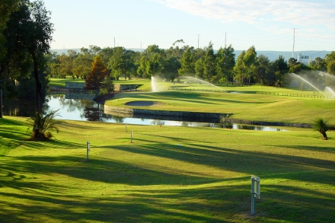


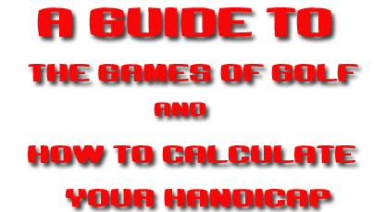
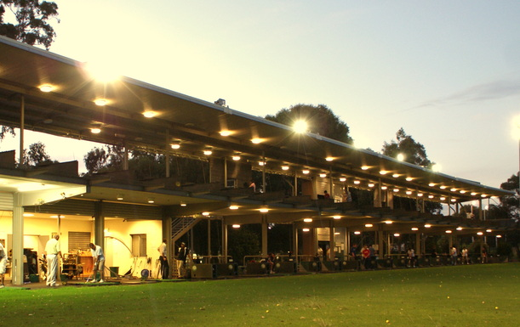

Whaleback has the Best Golf Coaches available!
Led by Peter Hopkins, WA Coach of the Year 2000.
Current Adult Clinic times:
Supervised Practice Clinics (NO BOOKINGS)
Monday 6-7pm cost $20pp Thursday 6.30-7.30pm cost $20pp
Wednesday 9.00-10.00am Men/Ladies Beginners $20pp Thursday 7.30-8.30pm cost $20pp
Wednesday 10.00-11.00am Men/Ladies Intermediate $20pp
Scott McLean - 0421 829 457 to register interest.
Friday Ladies Clinic 9.30am - 10.30am cost $20pp With Paul Fenton



